ASE LAB ASSIGNMENT 7

Lab ID: 6_2

Name: Udaya Byreddy

Student ID: 16293204

Class ID: 3

Partner Name: Madhuri Sarda

Student ID: 16291679

Class ID: 21

Agenda: CRUD operations on customer data using MONGO DB.

Customer details list page

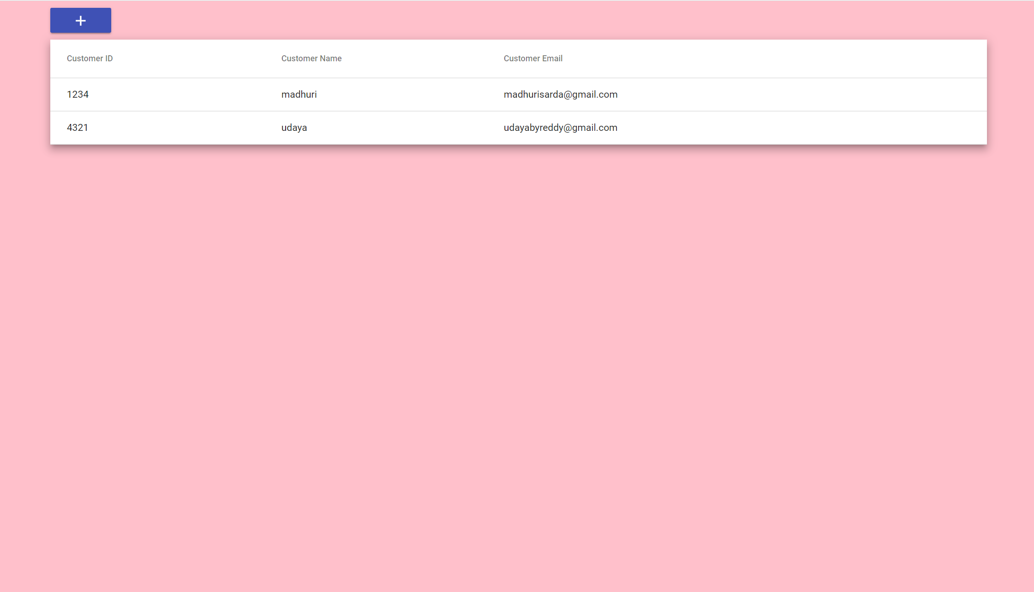

Customer details add page

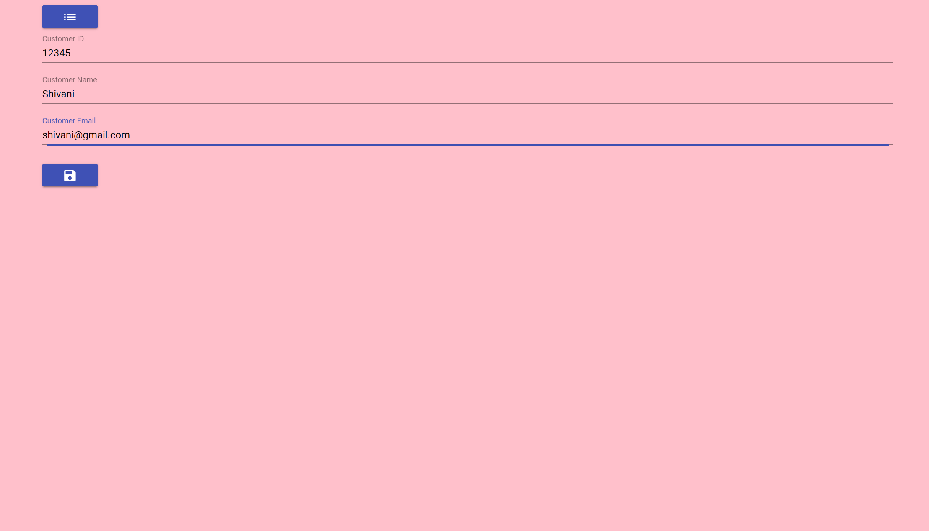

Customer details save page



Customer details page after adding new customer

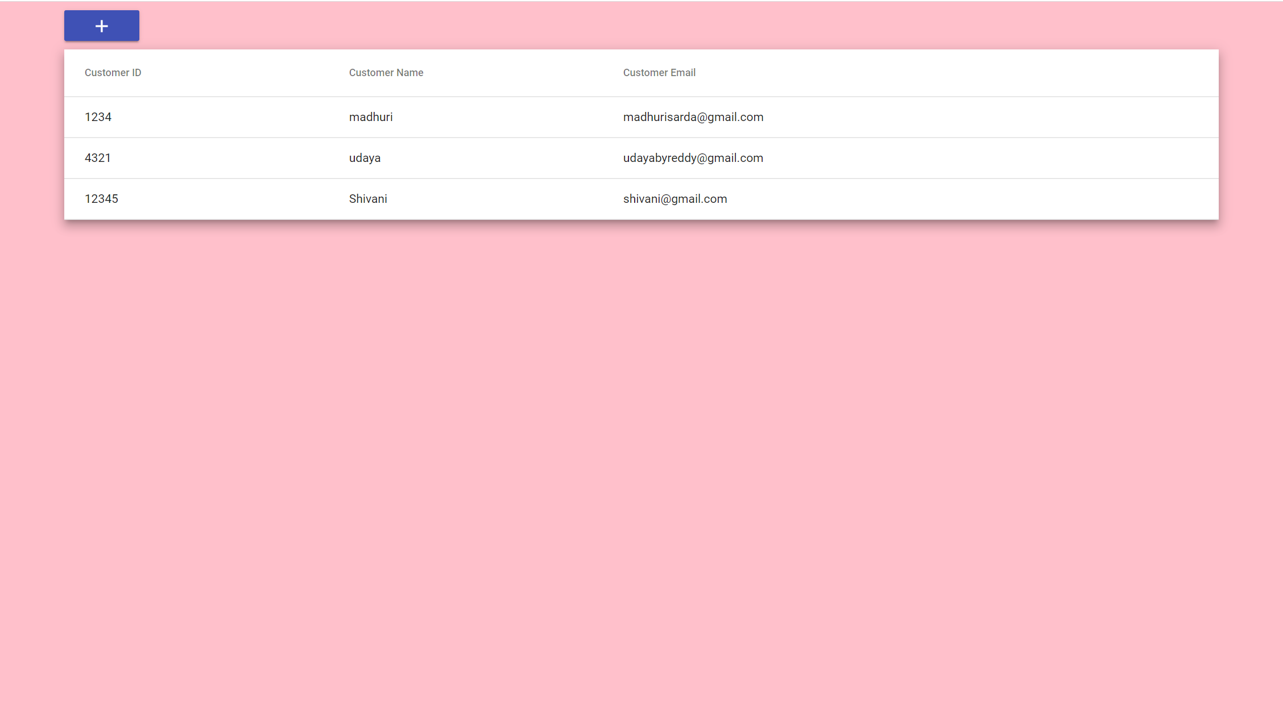

When clicked on customer details edit option will be enabled and can edit as seen in below screenshot

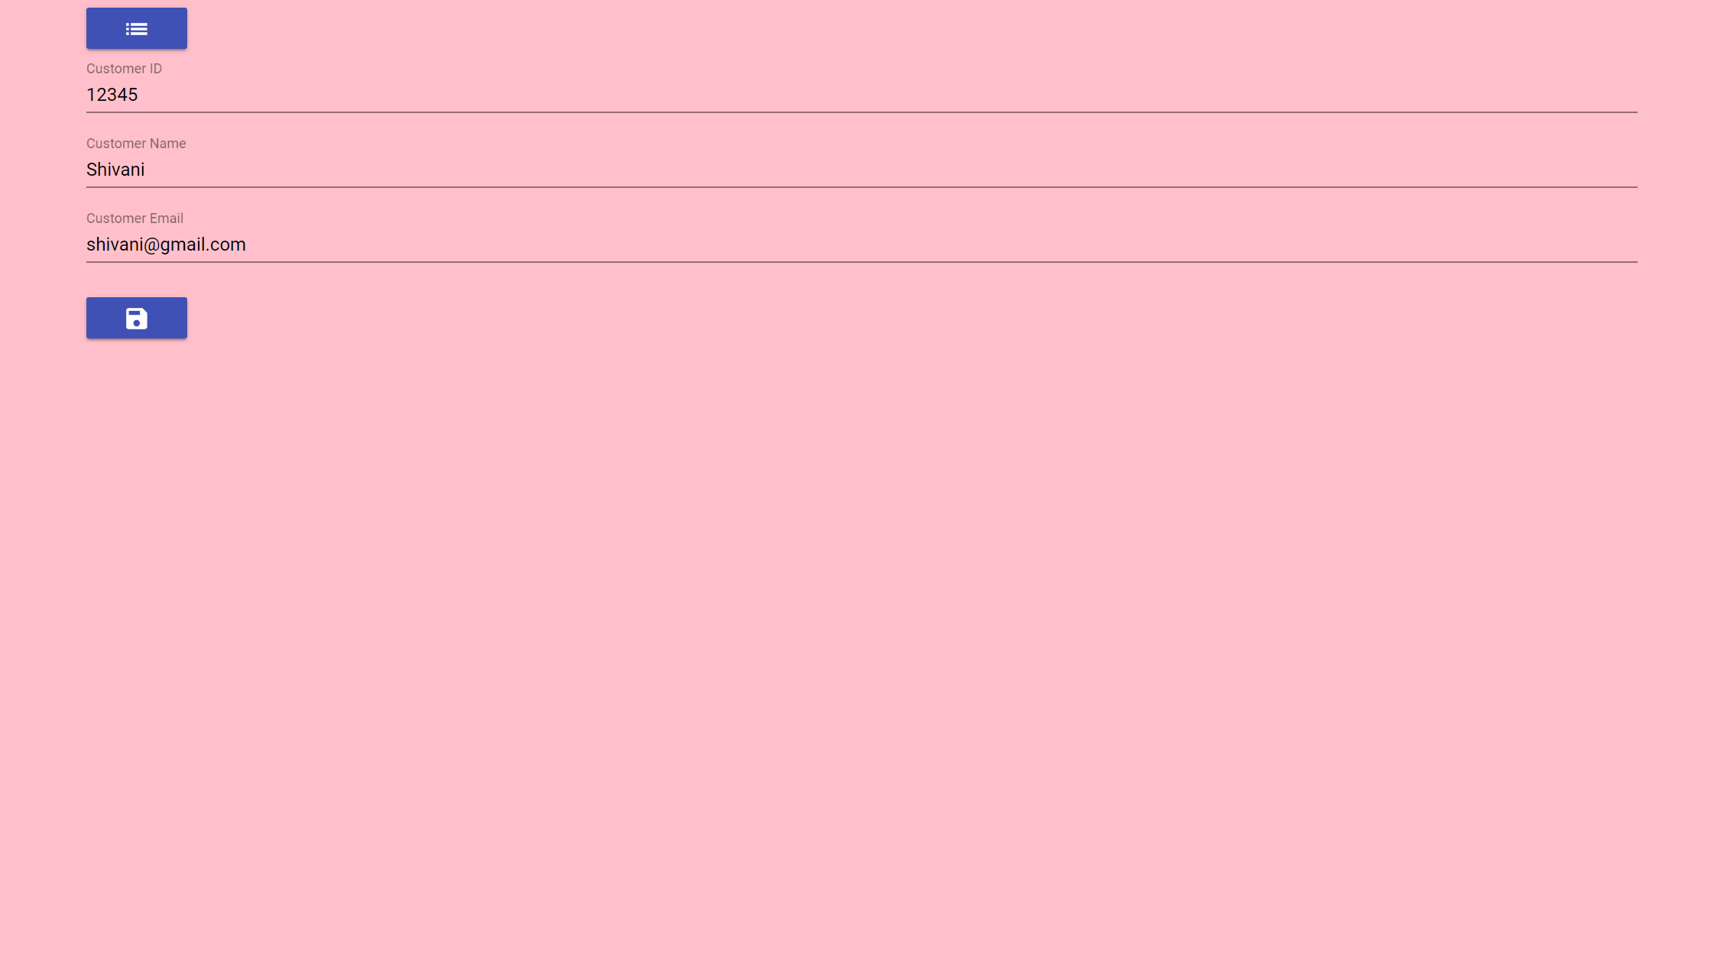

Customer details after editing a customer

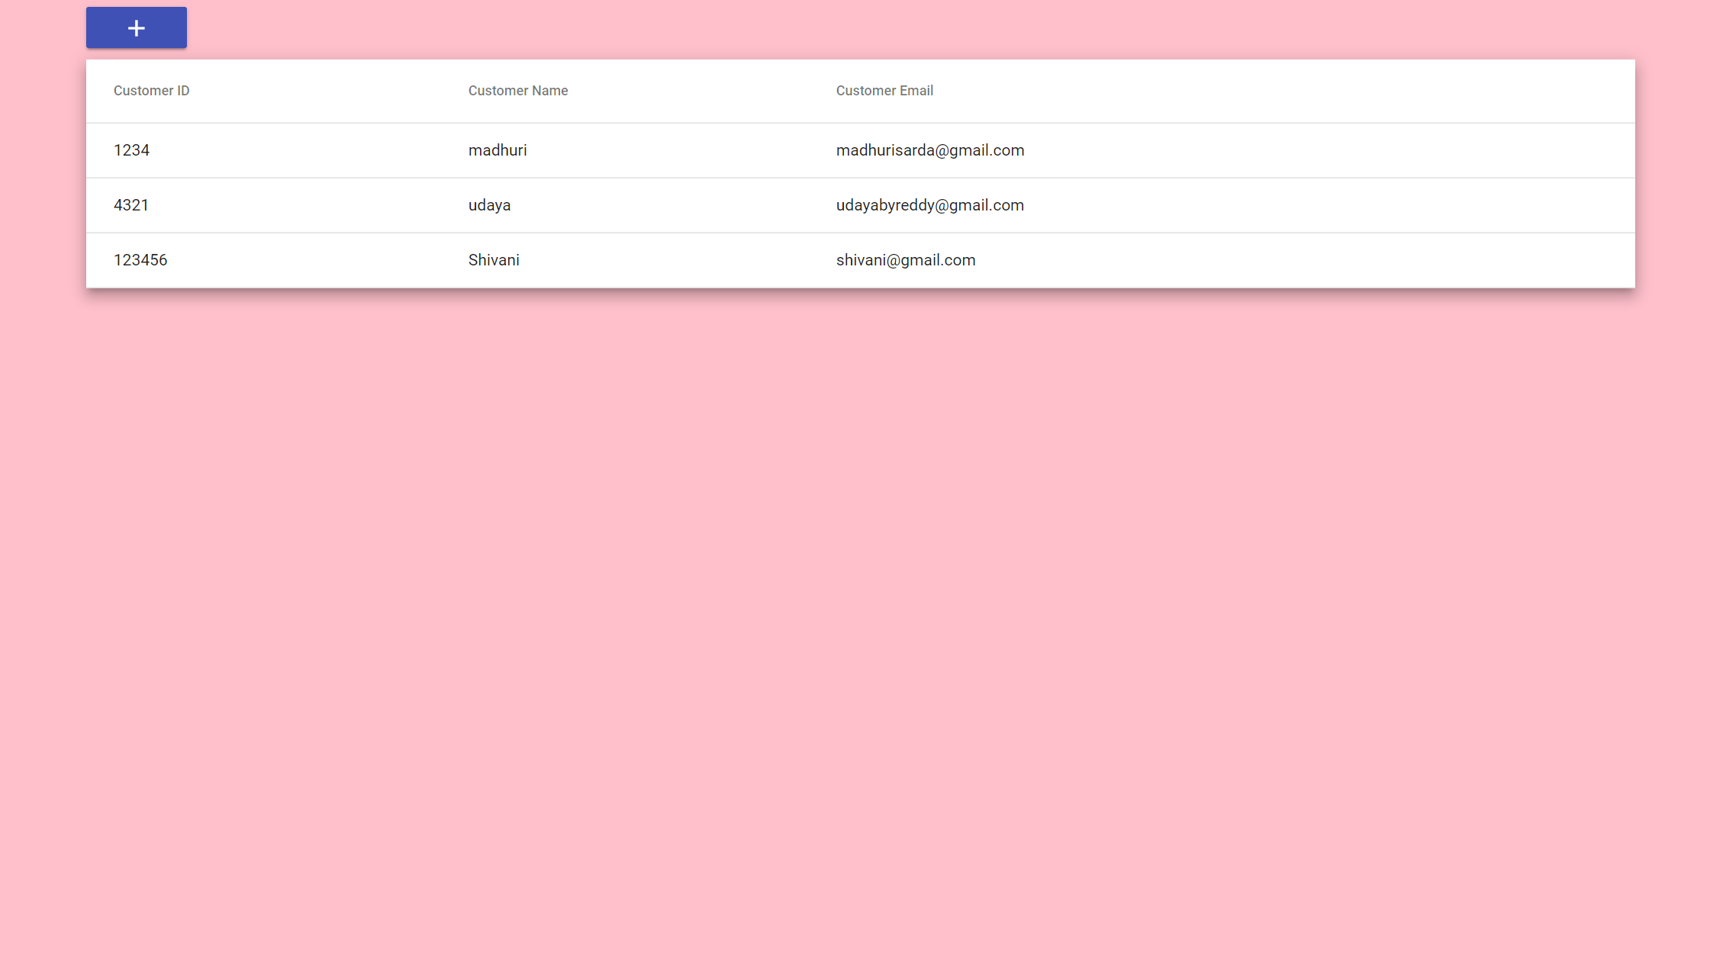

Customer details after deleting a customer

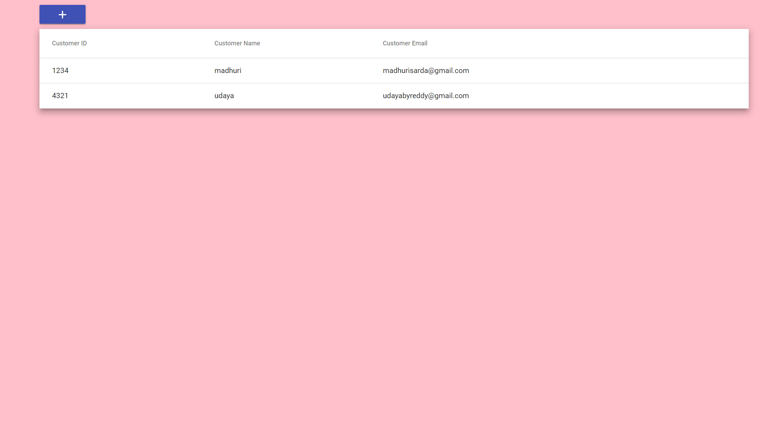

Here we are using MongoDB to store customer data. Below is screen shot of data getting stored in Mongo DB cloud.

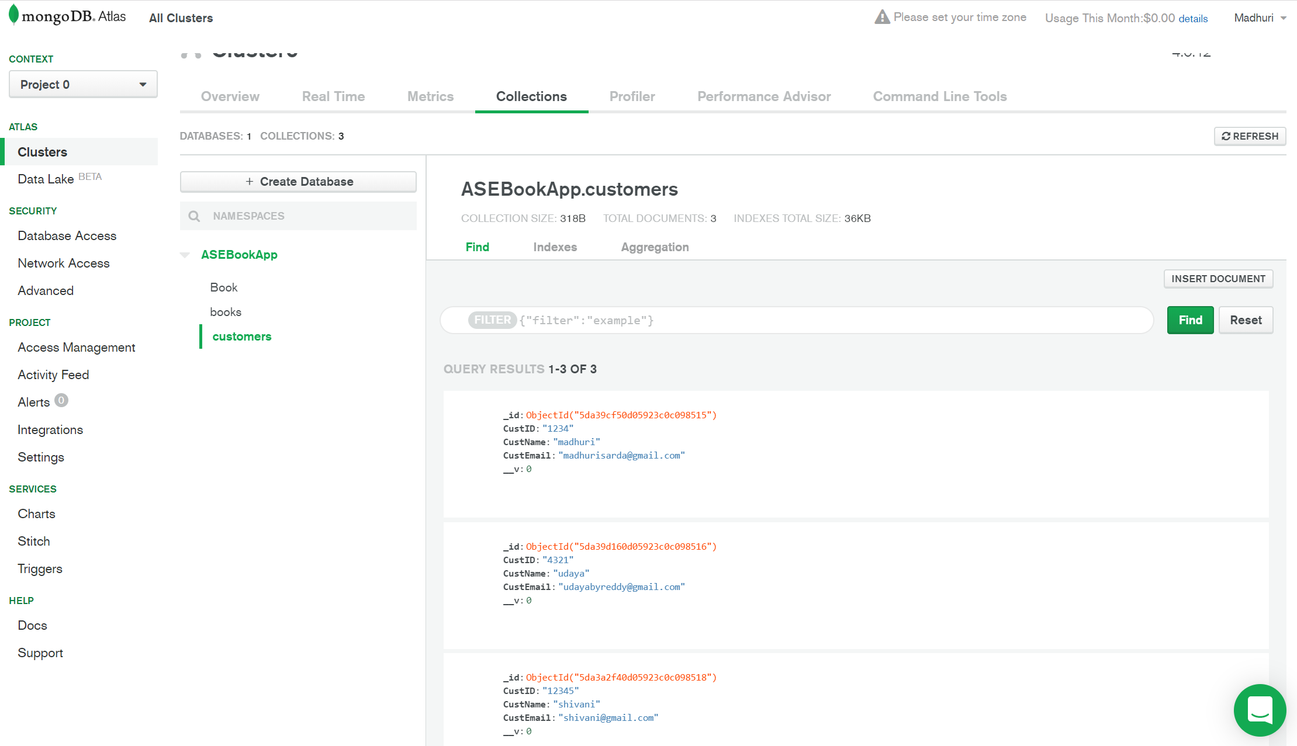

Mongo DB user credentials:

